In this case the client is configured to call a logical endpoint, the router in this case, which forwards the message to another server at runtime.
Routing can be implemented in hardware or software (e.g., Cisco's LocalDirector vs. Microsoft® Windows® NLB service), using a variety of different algorithms and networking protocols. Routing algorithms can perform anything from simple address translation to more advanced content analysis, where routing decisions are based on what's in the message (also known ascontent-based routing).
The fundamental benefit of routing is that of network virtualization, the ability to make the application's physical network topology transparent to the client. For example, the client in Figure 2 always sends messages to a logical endpoint (the router) and doesn't realize that the message is actually forwarded to one of three possible servers that are ultimately responsible for processing the request, as is the case with load balancing.
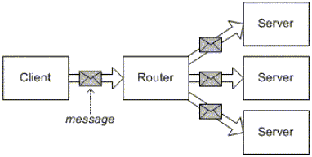

Figure 1Routing and load balancing

